**Name:____________________________**

**Writing Equations of Lines NOTES**

**Write the equation of a line given the slope and y-intercept. (**y = mx + b)

1) slope = -3, y-intercept = 2 2) slope = 5 y-intercept = -4 3) slope = , y-intercept = -6

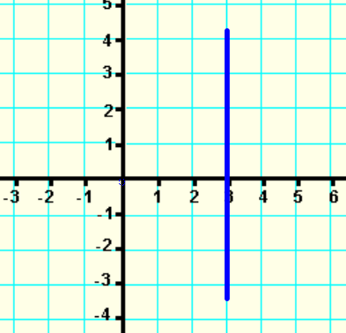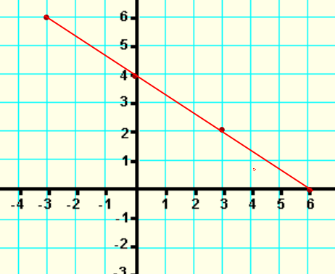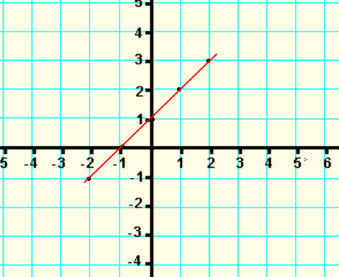4) 5) 6)

**Write the equation of a line given a table.**

|  |  |
| --- | --- |
| x | y |
| -2 | 2 |
| 0 | 4 |
| 2 | 6 |
| 4 | 8 |

|  |  |
| --- | --- |
| x | y |
| 5 | 3 |
| 6 | 5 |
| 7 | 7 |
| 8 | 9 |

|  |  |
| --- | --- |
| x | y |
| 0 | -2 |
| 5 | 0 |
| 10 | 2 |
| 15 | 4 |

7) 8) 9)

Slope = _____ y-int = ______ Slope = _____ y-int = ______ Slope = _____ y-int = ______

y = ____________ y = ____________ y = ____________

**Write the equation of a line given a slope and a point.**

10) m = 2; (0, 4) 11) m = ; (8, -2) 12) m = -3; (-3, 3)

**Write the equation of a line given two points.**

13) contains (-1, 0) and (2, -9)

14) contains (-5, 8) and ( 0, 10)

15) x-int = 4, y-int = -1

**Write an equation given the following.**

16) contains (2, 2) and is || to y = 2x + 5

m = _______

|| m = ______

⊥m = ______

y = _____________

17) contains (-2, 4) and is || to 2y = 2x - 4

m = _______

|| m = ______

⊥m = ______

y = _____________

18) contains (-1, 1) and is ⊥ to y = x + 9

m = _______

|| m = ______

⊥m = ______

y = _____________

19) contains (-2, -4) and is ⊥ to 2x –y = 2

m = _______

|| m = ______

⊥m = ______

y = _____________

20) contains (4, -6) and is ⊥ to x = 3

y = _____________