Name:________________
Unit 3 Test Review
Writing Equations

- What is the slope of the line containing the points (-1,4) and (3,2)?
a. -2 b. $\frac{1}{2}$ c. $\frac{-1}{2}$ d. 2

- Put the following equation in slope intercept form 2x – 5y = 10.
a. x – y = $\frac{-2}{5}$x - 2 b. y = - $\frac{2}{5}$ x + 2 c. y = -2x +10 d. y = $\frac{2}{5}$ x – 2

- In the equation y = -2x +5, name the slope and the y intercept.
a. slope $\frac{1}{2}$, y inter. 5 b. slope -2, y inter. 5 c. slope 5, y inter. -2 d. slope 5, y-inter. $\frac{1}{2}$

- Choose the best directions for graphing the equation y=$\frac{ 1}{ 2}$ x +1.
a. Graph the point (0,1) and count up 1 and to the right 2 to find another point on the line.
b. Graph the point (1,0) and count up 1 and to the right 2 to find another point on the line.
c. Graph the point (0,1) and count to the right 1 and up 2 to find another point on the left.
d. Graph the point (1,0) and count to the right 1 and up 2 to find another point on the line.

- What kind of line is created when you graph the equation x=2?
a. Horizontal line b. Oblique line c. Vertical line d. No line is created.

- What is the slope of the line x=2?
a. Zero b. Undefined c. 2 d. Not enough information

- Choose the equation of the line with a slope of $\frac{2}{3}$ and y passing through the point (6,-2).
a. y = $\frac{2}{3}$ x – 6 b. y = $\frac{2}{3}$ x – 2 c. y = $\frac{2}{3 }$ x - 4 d. y = $\frac{3}{2}$ x – 6

- Choose the equation of the line passing through the points (-2,3) and (-4,1).
a. y = x – 1 b. y = - $\frac{1}{3 }$ x + $\frac{7}{3}$ c. y = x – 4 d. y = x + 5

- Choose the equation of the vertical line passing through the point (-2,1).
a. x = -2 b. x = 1 c. y = -2 d. y = 1

- The table below represents a linear function. Use the table below to find the slope.
x | 0 | 2 | 4
y | 5 | 6 | 7

a. 0 b. 2 c. $\frac{1}{2}$ d. -2
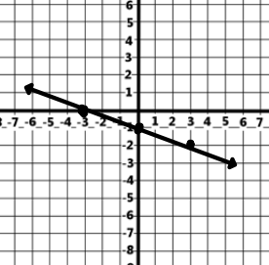
- What is the slope of the line to the right?
a. -3 b. - $\frac{1}{3}$ c. $\frac{1}{3}$ d. 3

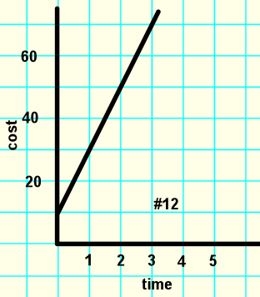
- The graph for a technician that charges a $10 flat fee plus an hourly rate is show below What is the hourly rate charged?
a. $12 per hour b. $9 per hour c. $5 per hour d. $20 per hour

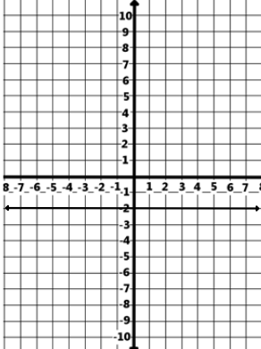
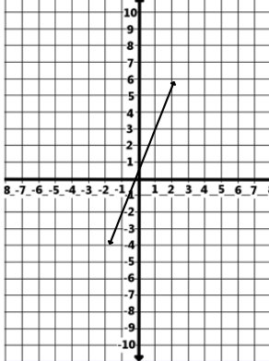
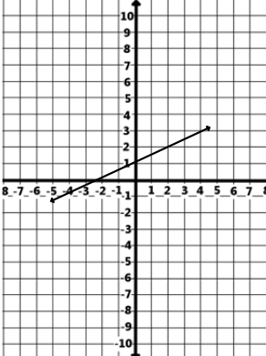
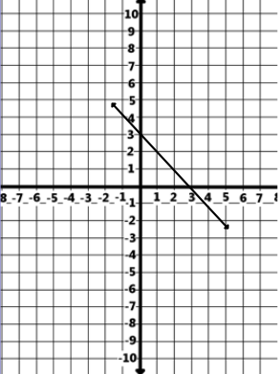
Line A Line B Line C Line D

Use the graphs for Lines A – D to answer questions 13 to 18.
13.__________ Which line(s) have a negative slope?

14.__________ Which line has a slope of zero?

15.__________ Which line has a x-intercept at (-2,0)?

16.__________ Which line has a slope of $\frac{1}{2}$ ?

17.__________ Which line is the graph of the equation y = 3x ?

18.__________ Which line is the graph of the equation y = -x + 3?

Solve for y for each of the following and then graph.
19. 2x – 3y = -9 20. 2y = 5x – 6 21. 4x – y = 7 22. 5x + y = 1
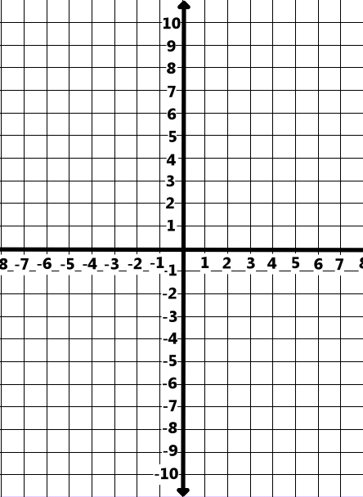

23) To help in estimating the number of customers for an amusement park attraction, the operators hired a market research group to visit several similar parks that had similar attractions. They found the pattern relating the price to the number of customers was linear. If the price was set at $15 they expected 26 customers, and if the price was set at $25 they expected 18 customers.

a) Identify the variables: x = ______________ y = _______________

b) Write two coordinates that represent the information.

c) Find the rate in price per customer. (slope)

d) How many customers would be expected if the price were free? (y-int)

e) Write an equation.

f) Write a Next/Now rule for the situation.

e) Use your rule to estimate the following.

i. price - $34 #customers - ___________ ii. price - $2 # customers - ________

iii. price - _______ # customers – 10 iv. Price - _______ # customers - 36

24) contains (-2, -2) and is ⊥ to y = x + 9 25) contains (-3, 4) and is || to 3y = 2x - 3
m = _______ m = _______
|| m = ______ ||m = _______
⊥m = ______ ⊥m = ______

y=________________ y=_________________

Find the a) slope b) y-int. c) rule for each of the following functions.
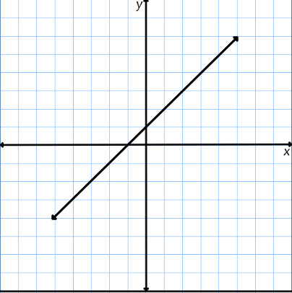
26) 27) a)
x | y
2 | 1
4 | -5
6 | -11
8 | -17
10 | -23

a) b)

b) c)

c)

28) (0, 3) (3, 9) 29) (3, -1) (6, -3)

a) a)

b) b)

c) c)

The Moon’s temperature decreases as you move from the surface toward the center. It decreases approximately 25 degrees for each kilometer beneath the Moon’s surface.

30) Complete the table below, showing the temperature as a function of distance beneath the Moon’s surface. Assume the temperature on the surface is 125 degrees.
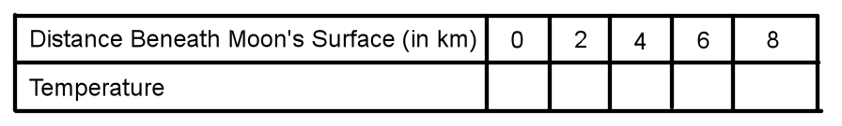

31) Write a Next/Now that shows how the temperature changes with each additional kilometer beneath the Moon’s surface.

32) Write a rule in slope intercept form.

33) The senior class is going on a trip to an amusement park and the rule P = 150 + 25n is used to find the total price of the trip.

a) Find the rate of change and explain what it would represent in the situation.

b) Find the y-int. and explain what it represents in the situation.

