Math 2 Practice on Polynomials : Day 1 (5.1-5.2)
Simplify:
1) x⁷ $∙$ x ³ $∙$ x 2) $\frac{6^{5}}{6^{3}}$ 3) (-2y⁵)² 4) 3x⁰ 5) (-3)⁻² 6) $\frac{5a^{7}}{-10a^{-2}}$ 7) (4x²)³(-3x)²

8) $\frac{18r^{3}s^{2 } + 36r^{2}s^{3}}{9r^{2}s^{2}}$ 9) (5x⁻³y²z)⁻² 10) $\frac{12X^{2}Y^{-5}}{2X^{2}Y^{-3}}$

Add or Subtract:
11) (4x³ + 5x – 7x²) + (-2x³ + 5x² – 7x) 12) (2x² + 7x – 10) + (3x² – 6x + 12)

13) (12x³ + 5x – 9) – ( -10x³ + 6x² - 5) 14) (5x² + 7x – 6) – (3x² + 7x + 10)

Multiply:
15) 5x²(6x + 1) 16) (3x+ 2)(2x -1) 17) (4x – 5)(x + 4) 18) (x + 4)(3x² + x – 1)

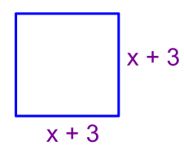
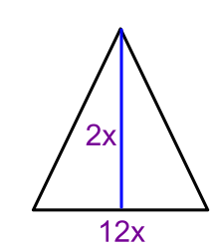
19) Find the area: A=lw 20) Find the area: A = $\frac{1}{2}$bh 21) Find the area: A = side²
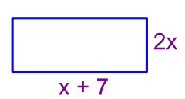

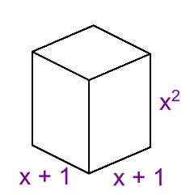
22) Find the volume of the prism: V=lwh

23) The number of pieces of furniture a certain furniture store sold since January can be modeled by the function N(t) = 10t + 4 and the price per piece of furniture can be modeled by P(t) = 2.5t2-12t+65, where t is the number of months since January. According to this model, what is the total amount of revenue generated by the furniture store’s sales in December? Round your answer to the nearest cent.
Hint: N(t) $∙$ P(t) and let t be the number of months passed

24) The number of books sold since 2005 at a book store can be modeled by the function N(t) = 5t + 36 and the price per book can be modeled by P(t) = 0.5t2-3.2t+8, where t is the number of years since 2005. According to this model, what is the total amount of revenue generated by the store’s book sales in the year 2011? Round your answer to the nearest cent.

25) A designer is making a rectangular prism box with maximum volume, with the sum of its length, width and height equal to 8 inches. The length must be twice the width. What should each dimension be? Round to the nearest tenth of an inch.

26) Find the area left for Leroy to grow corn in his garden. Use the picture below.
