**Name:________________________________**

**Power Functions Direct/Inverse Variation**

**Match each function rule to its corresponding graph, then write a sentence explaining the variation that relates x**

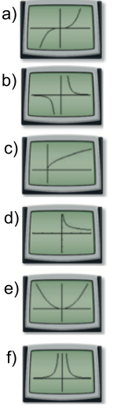**and y.** *(Example: y = * ***:*** *y varies inversely to the square of x with a constant variation of 6.)*

1) y = 0.5x2 Graph: ______

2) y = x3 Graph: ______

3) y = 3 Graph: ______

4) y =  Graph: ______

5) y =  Graph: ______

6) y =  Graph: ______

**Answer the following direct/inverse variation problems.**

**Steps: 1. Plug in given values to the correct direct/inverse variation rule (make sure to include any exponents or radicals)**

**2. Solve for k and re-write the new rule with the k value**

**3. Plug in the 2nd given value and solve to find the missing value**

7) If *y* varies inversely as the square of *x* and *y* = 9 when *x* = 2, find *y* when *x* = 3

8) If *r* varies directly as the square of *t* and *r* = 4 when *t* = $\frac{1}{2}$ find *r* when *t* =

9) If *y* varies inversely as the square root of *x* and *x* = 1.21 when *y* = 0.44, find *y* when *x* = 0.16

10) If *b* varies directly as the cube of *a* and *a* = 3 when *b* = 54, find *b* when *a* = 6.

11) If y varies directly as the square root of x and x = 9 when y = 48, find x when y = 16.

12) If y varies inversely as the cube of x and y = 8 when x = 1, find y when x = 2.