Worksheet for graphing absolute value
For each equation below, identify the coordinates of the vertex of the graph.
Do this without actually graphing.

1. f(x) = | 6x | 2. f(x) = - | 2x| 3. f(x) = - | x + 7 |
vertex:____________ vertex:____________ vertex:____________

4.f (x) = | x | - 9 5. f(x) = | 3x + 10 | + 12 6. f(x) = - | -5x + 7 | - 8

vertex:____________ vertex:____________ vertex:____________

Graph each function of absolute value
The graph of is like the alphabet V or upside down of it and the vertex is ( -b/a, c)
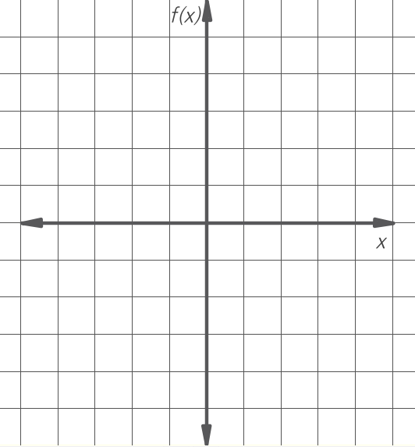
7. f(x) = | x | 8. f(x) = | x +4|
Vertex ( , ) Vertex ( , )
x | f(x)

x | f(x)

9. f(x) = | x | - 3 10. f(x) = | x +4| -3
Vertex ( , ) Vertex ( , )

x | f(x)
x | f(x)

11. f(x) = | x-2 | +1 12 . f(x) = | 2x +4| -5
Vertex ( , ) Vertex ( , )
x | f(x)

x | f(x)

Word Problems
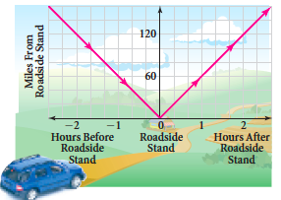
13) The graph at the right models a car traveling at a constant speed.
Which of the equations best represents the relation shown in the graph?
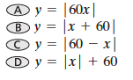

14) The conveyor belt at a factory operates continuously 24 hours a day, carrying vitamin bottles and moving two feet each minute.
a) Sketch a graph showing the distance in feet from the filling arm of one bottle on the conveyor belt
before and after it is filled. Use the x-axis for the time before and after the bottle is filled and the y
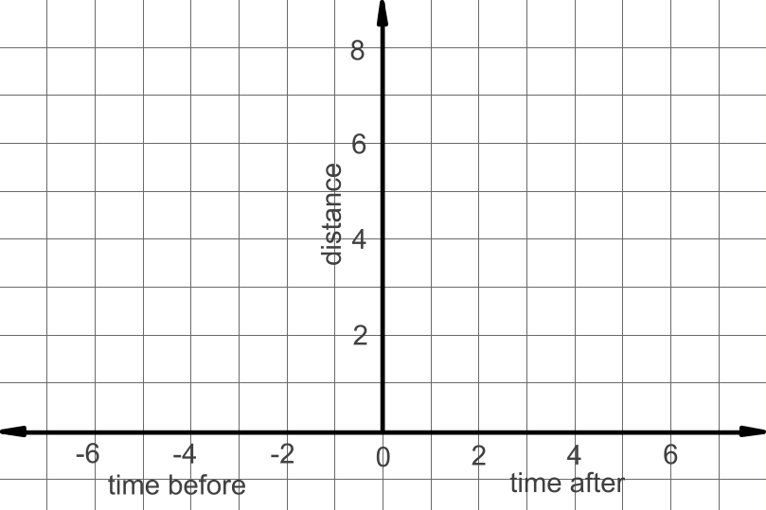
axis for the distance from the filling arm.

b) What would be the equation?

c) How far away from the arm with a bottle be if has 10 min.
before it gets to the arm?

14) A musical group’s new single is released. Weekly sales s (in thousands) increase steadily for a while and then decrease as given by the function s = -2|t – 20| + 40 where t is the time (in weeks).
a. Graph the function.

b. What is the maximum number of singles sold in one week?

c. What is the total sales after 25 weeks?

d. When will sales be at 24 thousand? (there are 2 x values)
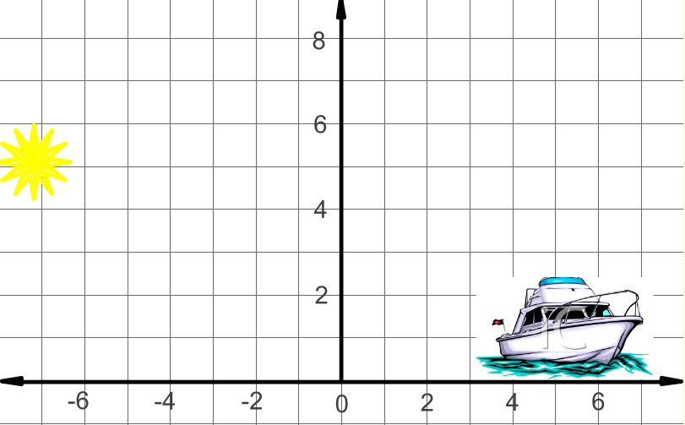

15) The sunlight reflected off a lake can also cause sun burn.
You are sitting on a boat at point (3, 2) and the sun reflects
off the water at (0, 0).

- Fill in the points that follows the path of the sun.

b) What would be the equation of the path of the sun?

