Math 2 Worksheet
Applications of Equations

1) The perimeter of a regular octagon is 124 inches. Find the length of each side.

a) Define a variable:

b) Write an equation:

c) Solve:

2) The length of a rectangle is twice its width. The perimeter is 60 inches.

- Define a variable:

- Write an equation:

- Find the length and the width of the rectangle.

- Find the area of the rectangle.

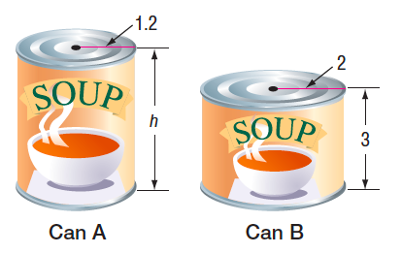
3) Two designs for a soup can are shown at the right. If each can holds the same amount of soup, what is the height of can A.

- First find the volume of can B using the formula V = πr²h.

b) Since the volume of the cans are the same, find the height of the
second can by plugging in the volume.

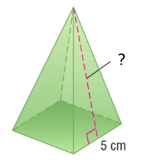
4) The formula for the surface area S of a regular pyramid is S = ½ PL + B, where P is the perimeter of the base, L is the slant height, and B is the area of the base. If the surface area of the square based pyramid shown is 105 cm², find the slant height.

- Identify the following variables:
S = P = L = B =

- Plug the values into the formula and solve for L.

5) The length of a rectangle is one more than twice its width, and the perimeter is 134 cm.

- Draw a rectangle and label its length and width given the information above.

- Write and equation and solve.

- What is the length and width of the rectangle?

- Find the area.

6) Given the following triangle, find the value of x, and then find measure of each angle.
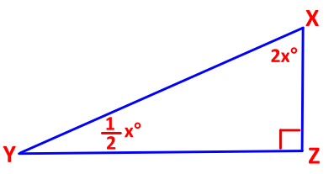
a) First set up an equation:

- Solve for x:

- What are the measures of the 2 acute angles? (Plug in the value of x).

7) A square has a side length that is 5 less than two times the value x. The perimeter of the square is 100 cm.
a) Set up an equation using the side length and the perimeter.

b) Find the value of x.

c) What length of each side of the square?

- What is the area of the square?

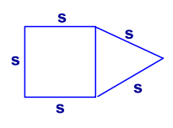
8) The Conte family is planning to put a railing around the deck in their backyard. The deck is in 2 pieces, a square and an equilateral triangle, which share a common side. They will buy 75 feet of railing to go around the outside of the deck. If the lumberyard will custom cut pieces of railing, how long should they have the pieces cut so that there is one piece for each side of the deck?

- define s=___________

- Write your equation to find s, using perimeter.

- Solve:

9) The length of a rectangle is 9cm more than half the width. Find the length if the perimeter
is 60 cm.

- define the length L=______________

- Write your equation for the perimeter of a rectangle, and the substitute in for the length.

- Solve for length =_________ and width=_________

10) The perimeter of a parallelogram is 52cm. What is the length of the longer side if the shorter side measures 10cm? P=2L+2W

