(Name:______________________________

Quadratic Functions

1) The Sky Concert in Peoria, Illinois, is a 4th of July fireworks display set to music. A rocket (firework) is launched with an initial velocity of 128.6 meters per second at a height of 3.8 meters above the ground.
a. Write an equation that represents the height of the rocket h after t seconds.

b. The rocket will explode when it reaches its maximum height. After how many seconds after launch will the
rocket explode?

c. What is the height of the rocket when it does explode?

d. Fill in the table to show the various heights
after t number of seconds. Then graph.
t | 0 | 2 | 4 | 6 | 8
h

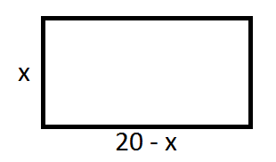
2) Miriam is building a pen for her dogs. The possible lengths and widths are represented in the diagram.
a. Write a function rule that represents the area of the dog pen.

A =

b. What value of x will result in the greatest area? (Maximum value)
What is the corresponding area?

c. Fill in the table and graph based on the function rule.
x | 0 | 5 | 10 | 15 | 20
A

Rule | Table | Max/Min | Graph
y = 2x² | -2 -1 0 1 2 |  | 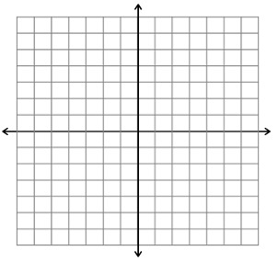
y = -x² + 5 | -2 -1 0 -1 2
y=3 – 8x + 2x² | 0 1 2 3 4
y=(x + 2)(x – 2) | -2 -1 0 1 2

