Name:______________________________
Math 1
Quadratic Word Problems
1) The length of a rectangular lawn is 6 feet longer than the width. The area of the lawn is 391 square feet. What the dimensions of the lawn?

2) The path of a projectile on the moon can be modeled by the function below, where t is the time (in seconds) and h(t) is the height (in feet). h(t) = -2.61t² + 48t + 5

a) How high was the object before it was thrown?

b) What is the maximum height? How many seconds does it take to reach this height?

c) How long does it take to land back on the moons surface?

d) If the same object was thrown on earth the path would be modeled by h(t) = -16t² + 48t + 5.
How long does it take this object to hit the ground?

3) A kicker kicks a football during practice. The equation below can be used to find the height (h) in feet of the football after t seconds. h(t) = -16t² + 32t

- What is the maximum height that the football reached?

- How many seconds did it take to reach the ground?

- How high is the football after 0.5 seconds?

4) A company’s profits are modeled by the function P(x) = -4.5x(x -10) + 18. P(x) is in thousands of dollars and x represents the number of units sold per month.

- What is the simplified version of the rule?

- How many units would have to be sold to make the highest possible profit?

c) What is the highest possible profit?
5) The equation a = 0.003x² – 0.115x + 21.3 models the average ages of women when they first married since the year 1940. In this equation a represents the average age and x represents the years since 1940.

- What was the average age of a women who married in 1940?

- What year was average age of brides the youngest?

- What is the youngest age?

6) What is the range of the function f(x) = (x – 2)² + 17

a) all real numbers greater than or equal to 2 b) all real number
c) all real numbers less than or equal to 17 d) all real numbers greater than or equal to 17
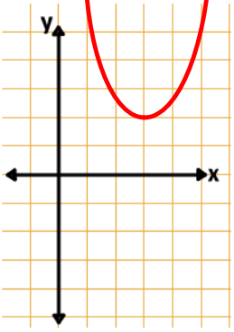
7) What is the domain of the function graphed?
a) all real numbers greater than or equal to 2x
b) all real numbers
c) all real numbers greater than or equal to 1 and less than or equal to 5
d) all real numbers greater than or equal to 3

8) Dale is 5 years older than Chip. The product of their ages is 266.

- Write a quadratic equation that will represent the ages.

b) How old is Dale? How old is Chip?

9) Clay built a dog pen based on the diagram below. The diagram is not drawn to scale.

- Write an equation that represents the area, then simplify and set equal to zero.
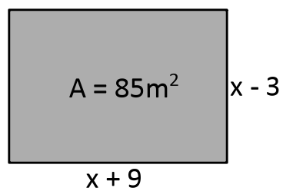

- What are the dimensions of the dog pen?

10) Vincent put his money into a mutual fund, where the amount of money he earned or lost can be found using the equation below, where M is the money Vincent earned or lost and x is time in years.
M = x² – 4x + 79

- If Vincent gained $100, how long did he have his money in a mutual fund?

- After how many years will he start to gain money?

- Will Vincent ever lose all his money in the mutual fund?
11) The equation s(t) = -4.9t² + 39.2t, models an object that is launched from ground level directly upward at 39.2m/s.

- What is the height of the object when it was launched? .

- What is the highest point the object reaches?

- If the object is in the air for 6 seconds?

- how long does it take the object to hit the ground?

12) A company’s profits are modeled by the function below, where profit p(x) is in thousands of dollars and x represents the number of units sold per month.
p(x) = -3.5x(x – 8) + 20

- Simplify the rule.

- What value of x will produce the maximum profit?

- What is the maximum profit?

13) The function y = 0.059x² – 7.423x + 362.1 models the consumption of bread and cereal by Americans, where y represents the bread and cereal consumption in pounds, and x represents the number of years since 1900. In what year was the lowest amount of bread and cereal eaten by Americans?
A. 1954 B. 1905 C. 1963 D. 1999

14) What is the range of the function f(x) = x² -14x + 64
A. all real numbers less than or equal to 15
B. all real numbers greater than or equal to 7
C. all real numbers greater than or equal to 15
D. all real numbers

15) Given f(x) = 4x² + 8x – 6, what is the domain of the function?
A. all real numbers
B. all real numbers greater than or equal to 2
C. all real numbers greater than or equal to 6
D. all real numbers less than 4

16) Phil hit 8 more homeruns than Charlie did last season. The product of their home runs last season is 180. How many home runs did Charlie hit last season?

