Name:______________________________

Midpoint and Pythagorean Theorem

Find the midpoint of each line segment.

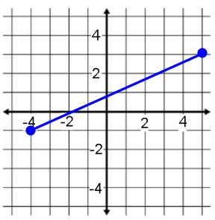
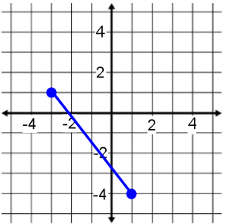
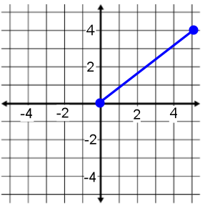
1) 2) 3)

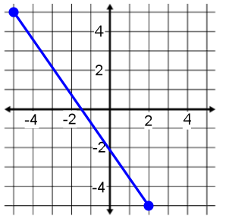
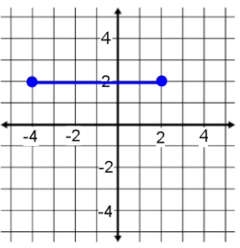
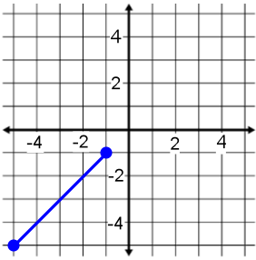
4) 5) 6)

Find the midpoint of the line segment with the given endpoints.

7) (-4, 4) (5, -1) 8) (-1, -6), (-6, 5) 9) (2, -1) (-6, 0)

10) (5, 2) (-4, -3) 11) (-3.1, -2.8) (-4.92, -3.3) 12) (-1, 1) (5, -5)

Find the other endpoint of the line segment with the given endpoint and midpoint.
13) Endpoint (-1, 9), midpoint (-9, -10) 14) Endpoint (2, 5), midpoint (5, 1)

15) Endpoint (5, 2), midpoint (-10, -2) 16) Endpoint (9, -10), midpoint (4, 8)

17) On a map’s coordinate grid, Merryville is located at (2, 4) and Sillytown is located at (2, -2). Bluxberg is the midpoint between Merryville and Sillytown. What is coordinate for Bluxberg?

18) Tonya is traveling to Peru for her summer vacation. She looks at a map of the path of her fight. Her plane leaves from Georgia, located at (5, 16) on the map’s coordinate grid, makes a stop at the halfway point, Panama, and then heads to its destination, Peru, located at (7, 8) on the map’s coordinate grid. Find the location of Panama on Tonya’s map.

19) Find the point that is one-fourth of the way from (2, 4) to (10, 8).

