Name:_____________________________

Graphing Worksheet #3

Solve each for y and then graph.

1) 2x – 2y = -4 2) 4y = -8x + 12 3) x – y = 5 4) -x – 3y = -6

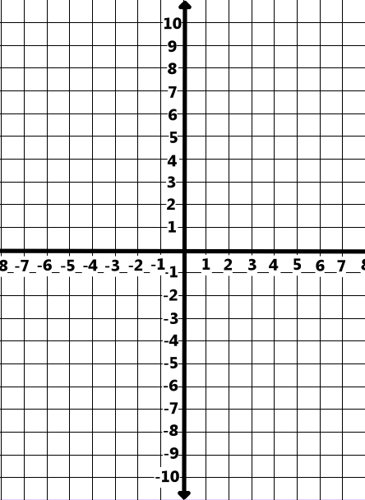

5) 5x + 3y = 3 6) 2x – 2y = 10 7) 5x – 4 = y 8) -2x + 3y = 12

9) 5y = 15 10) 3x – 4y = 20 11) 2x – y = -4 12) 6x + 4y = -16

13) (2, -4), m= 3 14) (-5, 0), m =$\frac{ -2}{3}$ 15) x-int= 3 16) x-int= -2
y-int= -5 y-int= 7

