Name:_____________________________

Graphing Worksheet #2

Solve each for y and then graph.

1) 2x + y = -4 2) 3y = -3x + 6 3) x – y = 2 4) -2x – 6y = -6

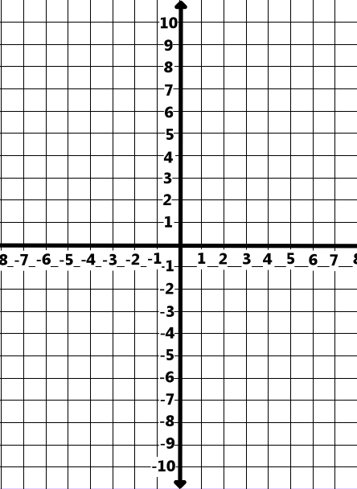

5) 2x + 3y = 6 6) 2x – y = 5 7) 3x + 1 = y 8) 3x + 4y = 12

9) 3x = -12 10) 2x – 3y = 9 11) 4x – y = -3 12) 3x + 4y = -8

13) (4,3), m= 2 14) (-2,4), m =$\frac{ -4}{5}$ 15) x-int= 4 16) x-int= -5
y-int= -8 y-int= 6

