Name:____________________

Math 1

Writing Equations

Write an equation in slope intercept form given the following information.

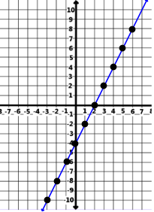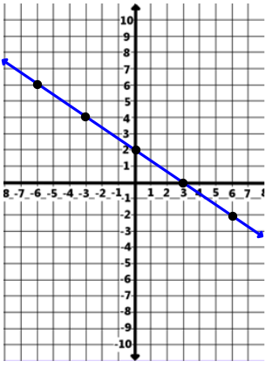1) m = 4; b = -4 2) m = ; b = 5 3) 4)

y = ___________ y = __________

y = ___________ y = __________

**Find the equation of the line that goes through the given point and slope.**

5) contains (2, 4) m = 3 6) contains (4, -3) m =  7) contains (-3, 9) m = -5

8) contains (4, 0) m =  9) contains (-2, -13) m =  10) contains (-3, 12) m = -4

**Find the equation of the line that goes through the following 2 points.**

11) contains (-1, -6) (1, 10) 12) contains (4, 0) (12, -2) 13) contains (10, -4) (15, -3)

14) contains (-1, -5) (1, 15) 15) contains (3, -6) (0, -5) 16) contains (-5, 5) (1, 5)

17) x-int = 2, y-int = 3 18) x-int = -4, y-int = 2 19) x-int = 6, y-int = -1