Name:_________________________________
Math 1 Unit 1 Test Review
Sketch a graph that shows the relationship between each independent and dependent variable.
1) The stretch of the bungee cord 2) The number of tickets sold for
depends on the weight the bungee attraction depends
attached to the cord. on the price per ticket.

3) The income from the bungee 4) The race time in the Dayton 500
attraction depends on the price depends on the rate of speed.
per ticket.

5) The total population in Brazil
depends on the given year.

6) The basketball team at your school is selling cookies as a fund-raiser. You need to decide how much to charge for each cookie. You take a poll and estimate the total number of cookies that you can sell at different prices. You found that for every 10 cents you increase the cookie price, the number of cookies sold drops by 100.
a. Fill in the rest of the chart based on the results from above.

Price per cookie (in cents) | 10 | 20 | 30 | 40 | 50 | 60 | 70 | 80
Number of cookies sold | 700

b. In this situation which variable is naturally independent and which is dependent? Explain your reasoning.

Independent:_________________________ Dependent:___________________________

Explanation:

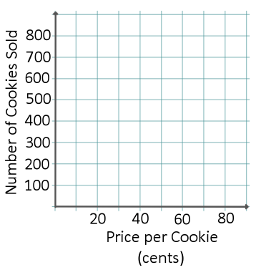
c. Plot the data from the chart on the coordinate grid.

d. Use the pattern in the table or graph to estimate the
price if it was set at 35 cent each.

e. Use the pattern in the table or graph to estimate the
cost if you only sold 50 cookies.

f. Describe as precisely as possible the overall pattern of change relating the cost per cookie and the
number of cookies sold.

g. The local bakery will donate 300 cookies for your sale. What should you charge per cookie so that you
sell them all? Explain your reasoning.
Cost per cookie: ________________
Explanation:

7) Pat competes in the 1600-meter run for his high school track team. Clearly the time it takes Pat to complete the run depends on his average running speed. Pat’s race time in seconds can be found by using the rule $t= \frac{1600}{s}$.
a. Complete the table below showing the way that race time and average speed are related.
Average speed  (meters per second) | 2 | 4 | 6 | 8 | 10
Race time
(in seconds)
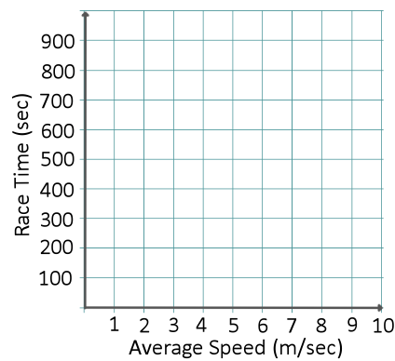
b. On the grid, make a graph that shows how race
time changes as average speed increases.

c. Describe the pattern seen in the table and the graph.

Use D = rt to answer questions 8 and 9.
8) If you drive your car at an average speed of 46mph, how many minutes will it take you to go 30 miles?

9) If it takes you 45 minutes to go 12 miles, what is you rate of speed in miles per hour?

Use the words NOW and NEXT to write rules that match the patterns in the tables below. Determine if the relationship is linear or non-linear.
12)
13) Linear or Non-linear? Explain.
x | 0 | 1 | 2 | 3 | 4
y | -4 | -2 | 0 | 2 | 4

Next = ____________________________________ starting at ________________

14)
15) Linear or Non-linear? Explain.
x | 0 | 1 | 2 | 3 | 4
y | 2 | 6 | 18 | 54 | 162

Next = ___________________________________starting at _______________

Combine like terms
15) a + 2a + 3a 16) 2y + 3x + 5y – 2x 17) m³ + 2m³ + 9m² – 5m²

18) 7(8a + 6) 19) 3(2a + 5b) + 6a 20) 6x – (2x + 3)

21) 22)

Evaluate each expression if x = 12, y = 8, and z = 3

23) x + y² + z² 24) 4x – yz 25)

Write an algebraic expression for each verbal expression.

26) six less than three times the square of y _____________________

27) twice the sum of a and b ____________________

28) four divided by the difference of n and 6 ___________________

29) four more than twice the number x ____________________

30) the square of the sum of n and five ____________________

