Name________________
Math 1 Quiz
Distance, Midpoint and Pythagorean Theorem

Using the distance formula find the length between the 2 given points. Simplify the radical if possible.
________1) (4,3) and (-3,4) __________2) (1,-9) and (6,-6)

Using Pythagorean Theorem find the missing side. Simplify each radical if possible.
_________3) a=4 b=8 c=? _________4) a=2 b=? c=8

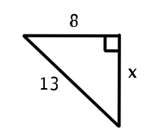
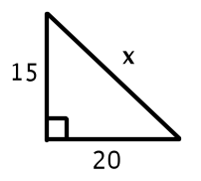
_________5) _________6)

Find the midpoint of the line segment with the given endpoints.
_________7) (-4,4) & (-2,2) _________8) (-1,1) & (5,-5)

Find the other endpoint of the line segment with the given endpoint and midpoint.
_________9) endpoint (2,-5), midpoint (5, -6)

_________10) endpoint (-4,-1), midpoint (-7,0)

Bonus: Given y=2x+1 AND y=-x+4, find the point of intersection. Ans;__________

