Name:___________________________________________
Pythagorean Theorem

Find the length of each missing side.
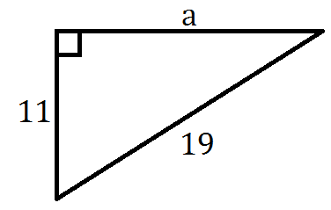
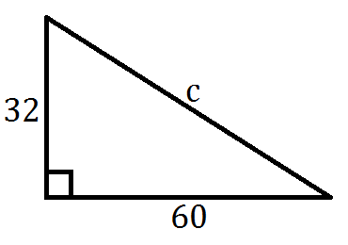
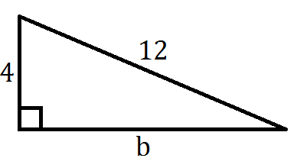
1) 2) 3)

If c is the measure of the hypotenuse of a right triangle, find each missing measure.

4) a = 24, b = 45, c = ? 5) b = 48, c = 52, a = ? 6) c = 27, a = 18, b = ?

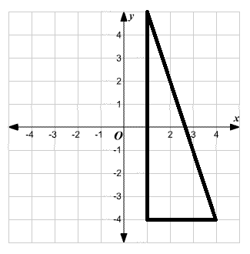
Find the hypotenuse of each triangle on the coordinate plane.
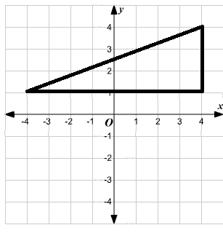
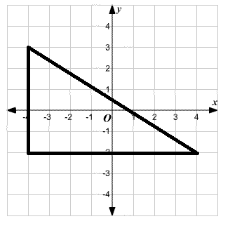
7) 8) 9)

For Questions 10 – 12, use the following information.
The size of a television is measured by the length of the scree’s diagonal

10) If a television screen measures 18 inches high and 24 inches wide, what size television is it?
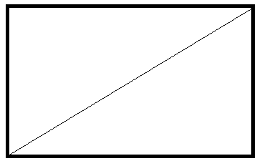

11) Darla told Tri that she has a 35-inch television. The height of the screen is 21 inches. What is the width?

12) Tri told Darla that he has a 5-inch handheld television and that the screen measures 2-inches by 3-inches. Is this a reasonable measure for the screen size?

