Name:______________________________________

Area Review
Match the names at the left with the figures at the right. Some figures are shown more than once, therefore will be an answer for more than one name.
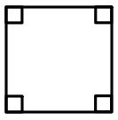
1) Right triangle – _________________ a) b)

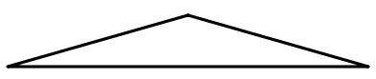
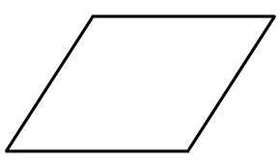
2) Triangle- ____________________ c) d)

3) Rectangle - _____________________
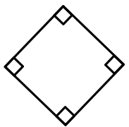
e) f)
4) Square - _____________________

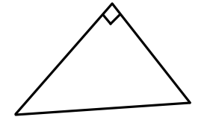
5) Parallelogram - ________________________ g) h)

6) Trapezoid - _______________________
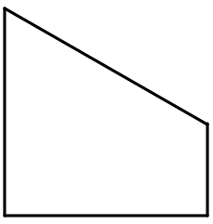
7) Circle - _________________________ i) j)

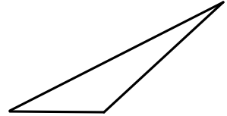
k) l)

Find the PERIMETER of each figure shown below.
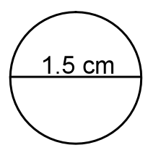
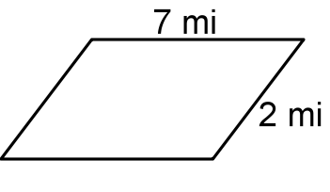
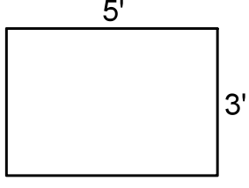
8) 9) 10)

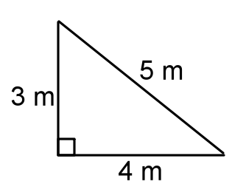
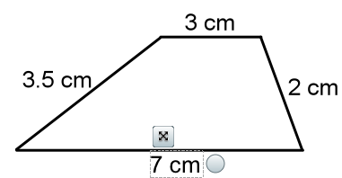
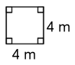
11) 12) 13)

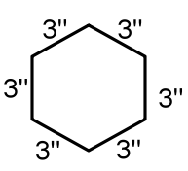
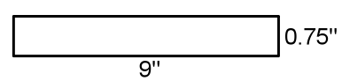
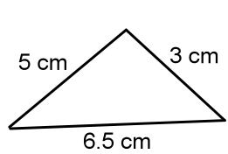
14) 15) 16)

Determine-or estimate- the AREA of each of the figures shown below, using the fact that each square of the grid has an area of one square centimeter.
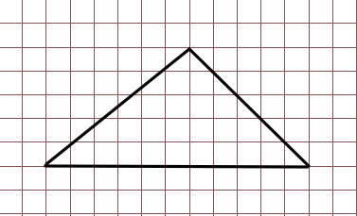
17) 18)

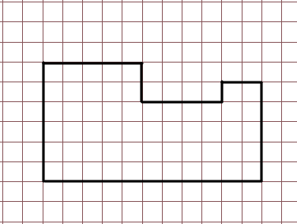
19) Match the figure on the left with the correct
area formula. Use each answer only once.

20) Square a) A= $\frac{1}{2}$ (base)(height)

21) Rectangle b) A = $π×$(radius)²

22) Triangle c) A = (base)(height)

23) Parallelogram d) A = (length)(width)

24) Trapezoid e) A = (side)²

25) Circle f) A =

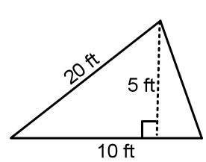
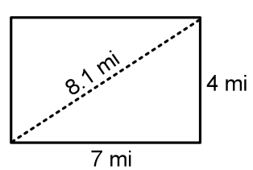
Find the area of each figure below.
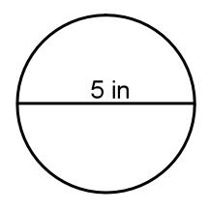
26) 27) 28)

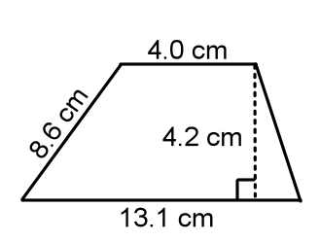
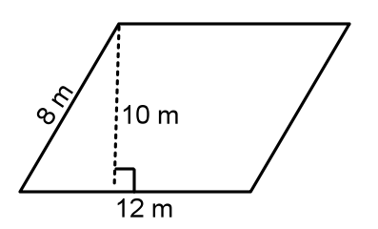
29) 30)

